**Ideation Phase: Brainstorming & Idea Prioritization Template**

|  |  |
| --- | --- |
| Date | 13 June 2025 |
| Team ID | LTVIP2025TMID32074 |
| Project Name | sustainable smart city assistant using ibm granite llm. |
| Maximum Marks | 4 Marks |

**Part 1: Ideation**

**Phase — Brainstorming & Prioritization**

**✅ Step 1: Team Gathering & Problem Statement**

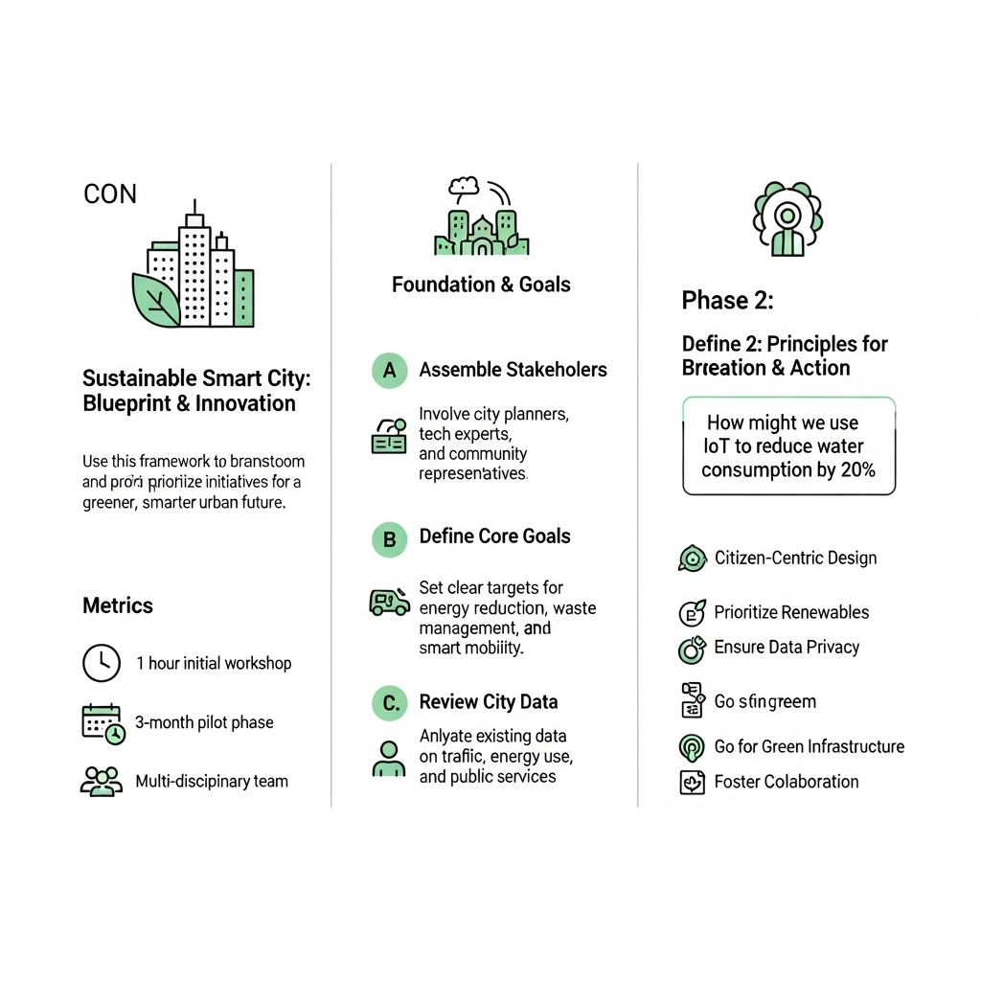

* The team gathered via Google Meet on 31 January 2025.
* Collaboratively selected the core problem statement:

*"How can we use AI to enhance urban sustainability and citizen services in a smart city?"*

**✅ Step 2: Brainstorming & Idea Listing**

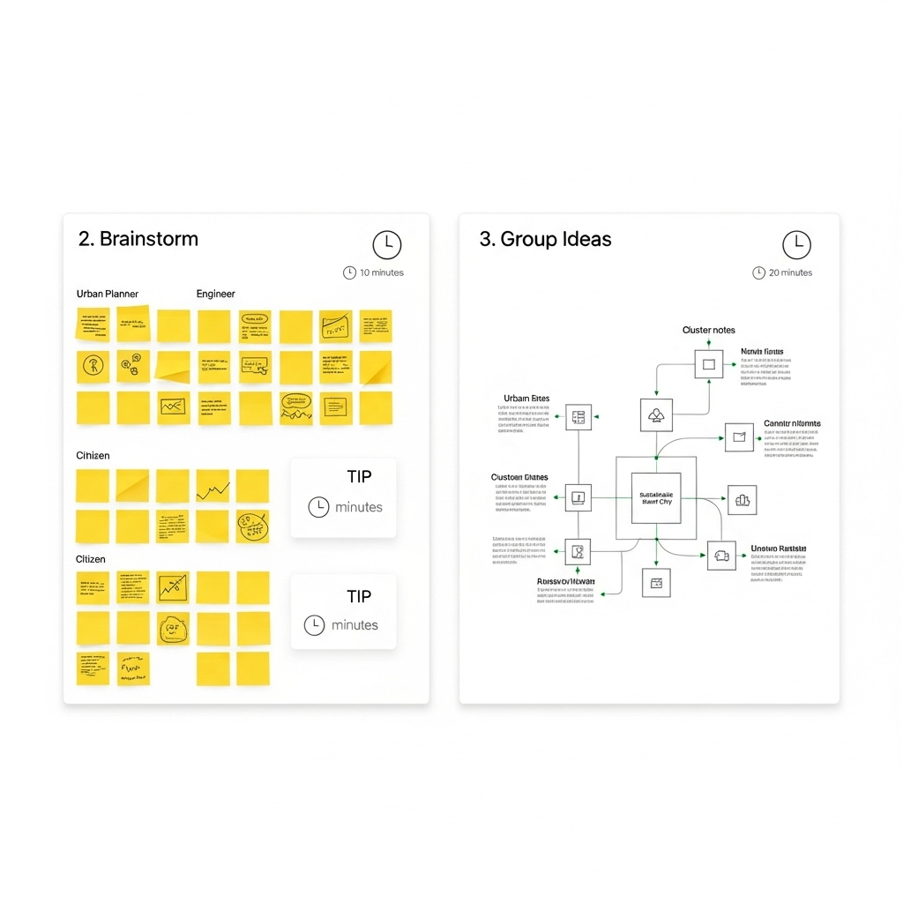

* Total ideas generated: 25+
* Ideas were grouped into the following categories:

| **Category** | **Sample Ideas** |
| --- | --- |
| Assistant Features | AI Chat Assistant, Eco-Tips Bot, Voice Interface |
| Waste Management | Smart Bin Alerts, Garbage Collection Scheduling |
| Dashboard Modules | KPI Tracker, Real-Time City Health Dashboard |
| Citizen Engagement | Feedback Form, Issue Reporting, Green Score Gamifier |

**✅ Step 3: Idea Prioritization**

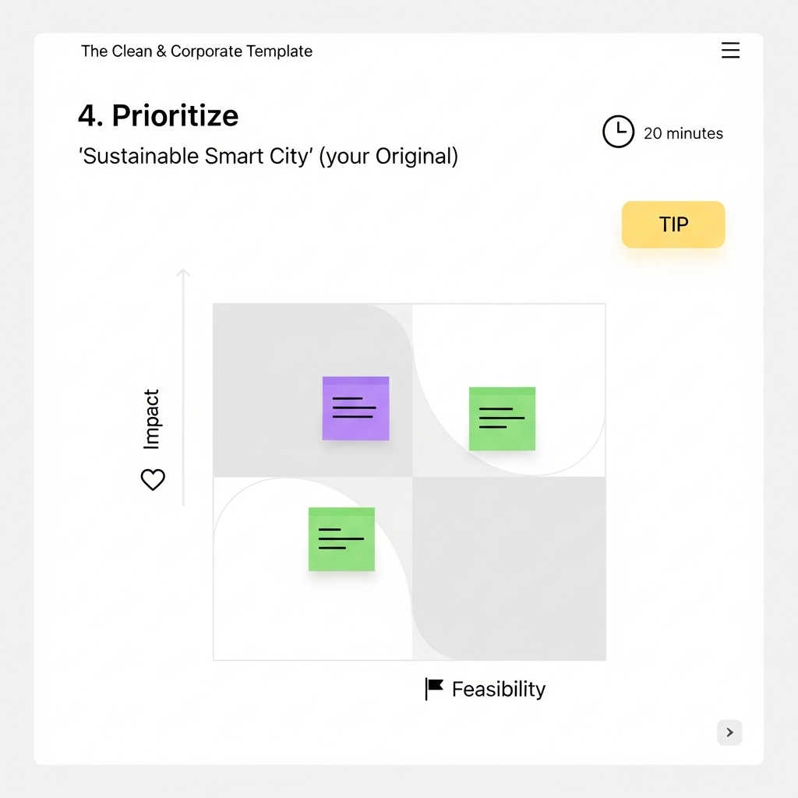

* Method: Impact vs Effort Grid

| **Idea** | **Category** | **Feasibility (1–5)** | **Impact (1–5)** | **Priority** |
| --- | --- | --- | --- | --- |
| Eco-Tips Chatbot | Assistant Features | 4 | 5 | High |
| Smart Waste Notification | Waste Management | 4 | 5 | High |
| Real-Time KPI Dashboard | Dashboard Modules | 3 | 5 | Medium |
| Feedback Form | Citizen Engagement | 5 | 4 | High |
| Green Score Gamification | Citizen Engagement | 3 | 3 | Low |

* **High Priority Ideas** selected for MVP:
  + Eco-Tips Chatbot
  + Smart Waste Notification System
  + Feedback Collection Form